5.93: a) The only horizontal force on the two-block combination is the horizontal component of 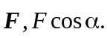 The blocks will accelerate with 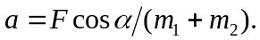 b) The normal force between the blocks is 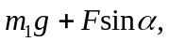 for the blocks to move together, the product of this force and 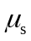 must be greater than the horizontal force that the lower block exerts on the upper block. That horizontal force is one of an action-reaction pair; the reaction to this force accelerates the lower block. Thus, for the blocks to stay together, 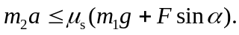 Using the result of part (a),
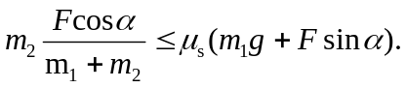
Solving the inequality for F gives the desired result.

